TNE20003 – Internet and Cybersecurity for Engineering Applications

Portfolio Task – Lab 5 Distinction Task

Aims:
- Explain & understand NAT at deeper level

Preparation:
- View “NAT & DHCP”

Due Date:
- Your Task will be assessed via an online quiz. You must score the required minimum to pass the test. You will be allowed a number of attempts to pass the test at the grade level you attempt. You are encouraged to complete the test at the end of the lab but if you do not, you must complete it before your next lab class.
.

Task 1.
Build the network provided in figure 1 with Cisco Packet Tracer
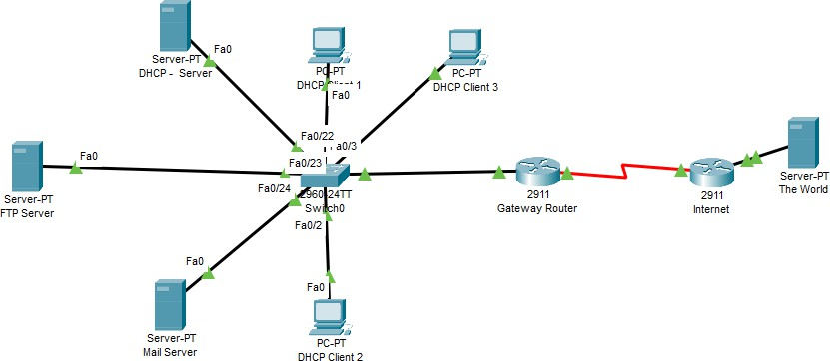
Figure 1
To attempt the D task you must have completed the P and C tasks. Use the network you built and tested in the Credit task for lab 5 to test and answer the following questions.

Task 2.
- You have implemented NAT successfully in the Pass task.
  - Now generate some traffic by pinging from DHCP Client 3 to The World server located at 136.186.100.2. What happens?
Ping will be successful as the IP given by DHCP server is within the access-list and permitted on the gateway router allowing for NAT translation to external communication.
  - Are there any address translations on the Gateway Router# prompt? Explain
Yes – translations of given DHCP ip address to the public NAT IP.
  - Ping The World server located at 136.186.100.2 from the ftp server. What happens?
Pings will not be successful – 192.168.1.252 is not within the access-list wildcard mask range

  - How far does the ping from the ftp server propagate through the network?
With no configuration of default gateway of FTP server, ping does not leave the FTP server.
With default gateway the ping will reach the destination but an echo-reply will not reach the FTP.
  - Were there any translations on the Gateway router? Explain why/why not.
No translations because the FTP ip address is not permitted by the IP access-list on the gateway router
  - Change the IP address of DHCP Client 3 to a static address of 192.168.1.80. Ping The World
server located at 136.186.100.2 from this PC. What happens?

Ping will be successful as 192.168.1.80 is permitted by the access-list because it is within the range specified by the wildcard mask.

  - Part of your output should be as shown in the picture below:
  - What does the :5 represent?
The port number
  - Now ping from DHCP Client 2 and see the translations. What do you see?
  - What does inside local mean?
The private IP address of the PC
  - Change the IP address of DHCP Client 3 to a static address of 192.168.1.180. Ping The
World server located at 136.186.100.2 from this PC. What happens?

Ping will be unsuccessful for the same reason the FTP server was unable to ping 136.186.100.2
  - Were there any translations on the Gateway router? Explain why/why not.
No, access-list does not permit the Ip address as it is outside the wildcard mask range.
~~~~~ End of Lab ~~~~~

